User Authentication

Overview
caB2B needs that whoever wants to query secure data services or wants to have his own account in caB2B, must have a valid grid account. This is required because the secure data services executes the queries arrived from the valid grid users only. If user wants to query such secured services, he/she will have to login to caB2B client using the valid grid account. The user’s grid credential will then be used to execute the queries on secured services.

Also, the user’s grid identity is used to uniquely identify the user in the caB2B environment. This identity is used to create the user’s account in caB2B. Once the account is created, user can save the queries, experiments and reuse them whenever he logs in next time. The queries and the experiments created by the user will be private and only the creator of those could refer them.

For authentication purpose, caB2B uses the existing grid security infrastructure. Following is a diagram that depicts the authentication process of caB2B.

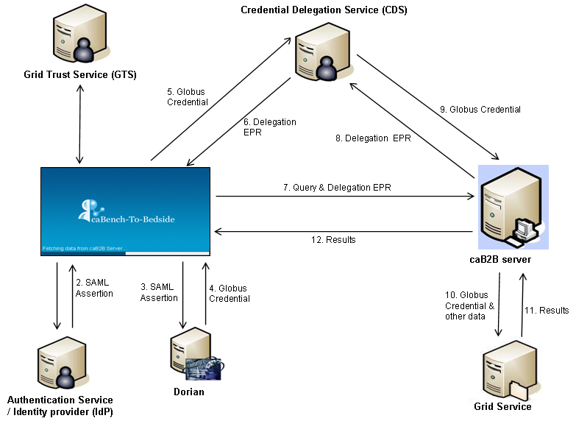

Figure 1 User authentication

- Credentials provided by the user is passed for verification to the corresponding Authentication Service/Identity Provider of selected grid. In this process, client first gets synchronized with the GTS to generate Trusted Certificate in USER_HOME/.globus/certificates folder. If a resource has a certificate signed by a new trusted CA certificate any clients connecting to this resource will need to have the new trusted CA certificate installed. The certificates in this directory correspond to certificate authorities that you trust for issuing credentials.
- The Authentication Service/Identity Provider returns the SAML Assertion if the user is verified as positive.
- The received SAML Assertion is then passed to the corresponding Dorian to ensure the IDP is trusted by the dorian.
- Dorian in response returns a temporary certificate called Globus Credential or Grid Proxy, which is used as an identity of the active user for a specified period (Default is 12 hours).
- The Globus Credential is delegated to Credential Delegation Service (CDS) for the secure storage and later retrieval by delegatee (caB2B Server) as and when needed.
- In return CDS provides a unique Delegation End-Point-Reference (EPR) which will be used by delegatee to fetch the correct Globus Credential from CDS.
- Along with the query, the received Delegation EPR is passed to the caB2B server for execution.
- caB2B server uses Delegation EPR to get the Globus Credential of the user.
- After validating the Delegation EP, CDS returns the Globus Credential for that user to caB2B server.
- Along with the generated DCQL, the Globus Credential is handed over to Federated Query Engine for execution. This Globus Credential is also used by caB2B server to create the account for the user in caB2B to which all the queries and experiment later created by him/her gets associated.
- Grid service authenticates and authorizes the user by verifying his/her Grid Credential against the GTS; if authorized and allowed, the CQL is executed and the results are returned back.

Classes Involved

Action Classes:

LoginAction.java: It calls the authenticator.java class with username and password as parameter and gets the user object as return type if user is a valid user or else gets an exception.

Common Classes:

Authenticator.java: It has many different methods for creating credentials, getting SAMLAssertion certificate and getting globusCredentials for the user.

GTSSynchronizer.java: This class does the work of synching with GTS and gets the GTS certificates. It also sees for the signing policy used by the user.

Sequence diagram:
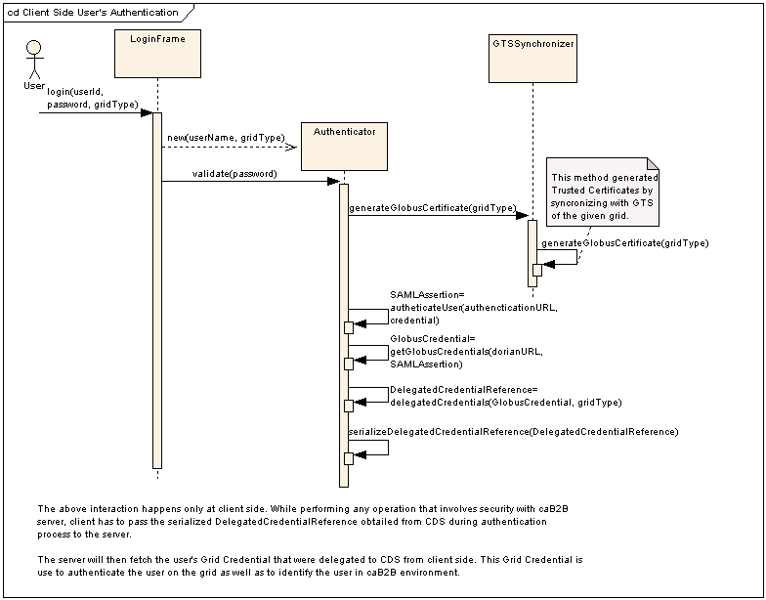
Figure 2 Sequence diagram of User Authentication

